A NOVEL STRUCTURE FOR SINGLE-SWITCH NONISOLATED TRANSFORMERLESS BUCK–BOOST DC–DC CONVERTER
ABSTRACT
A novel transformerless buck–boost dc–dc converter is proposed in this paper. The presented converter voltage gain is higher than that of the conventional boost, buck–boost, CUK, SEPIC, and ZETA converters, and high voltage can be obtained with a suitable duty cycle. In this converter, only one power switch is utilized. The voltage stress across the power switch is low. Hence, the low on-state resistance of the power switch can be selected to decrease conduction loss of the switch and improve efficiency. The presented converter has simple structure, therefore, the control of the proposed converter will be easy. The principle of operation and the mathematical analyses of the proposed converter are explained. The validity of the presented converter is verified by the experimental results.

BLOCK DIAGRAM FOR PROPOSED SYSTEM
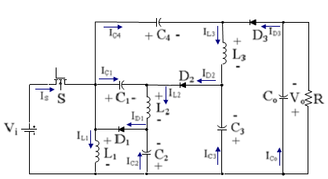
Fig. 1. Equivalent circuit of the proposed converter.
DESIGNG SOFTWARE AND TOOLS:
MAT LAB /SIMULATION Software and simu power systems tools are used. Mainly control system tools, power electronics and electrical elements tools are used.

